Exercise 1: Setting Up Junit

**Main class:**

**public** **class** Junit5setup {

}

Junit test class:

import static org.junit.jupiter.api.Assertions.*;

import org.junit.jupiter.api.AfterAll;

import org.junit.jupiter.api.BeforeAll;

import org.junit.jupiter.api.Test;

class TestJunit {

@Test

void test() {

//fail("Not yet implemented");

}

}

Pom.xml file

<project xmlns="http://maven.apache.org/POM/4.0.0" xmlns:xsi="http://www.w3.org/2001/XMLSchema-instance" xsi:schemaLocation="http://maven.apache.org/POM/4.0.0 https://maven.apache.org/xsd/maven-4.0.0.xsd">

<modelVersion>4.0.0</modelVersion>

<groupId>junit</groupId>

<artifactId>Junit5setup</artifactId>

<version>0.0.1-SNAPSHOT</version>

<dependencies>

<dependency>

<groupId>org.junit.jupiter</groupId>

<artifactId>junit-jupiter-api</artifactId>

<version>5.12.0</version>

<scope>test</scope>

</dependency>

</dependencies>

</project>

Output:

By default it will fail the test case

1.

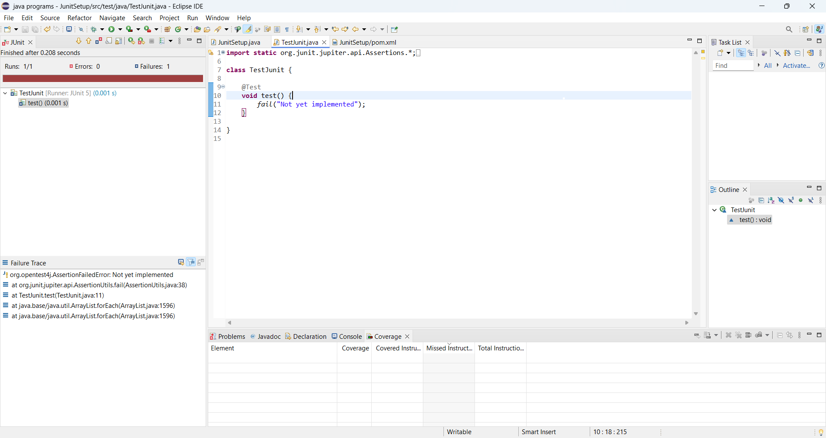

2. 